

Active Lives   
Children and Young People

Teacher

Questionnaire Summary 2024-25

# Introduction

This document has been created to summarise the content of the Active Lives Children and Young People questionnaire for teachers. Only one teacher per school needs to complete the questionnaire.

The teacher survey provides context for pupils’ responses and reduces the need to ask children questions that can be answered once by a teacher, e.g. questions that are common to the school.

Responses from the teacher survey are also used in the school report so if it is not completed there will be missing information in the school report. It is therefore also important that the teachers enter the correct URN to make sure that their responses are associated with the right school.

Additional information is highlighted in blue italic text.

# Homepage

On entering the URL, teachers will see the following screen.

They should select ‘Next’ to continue.

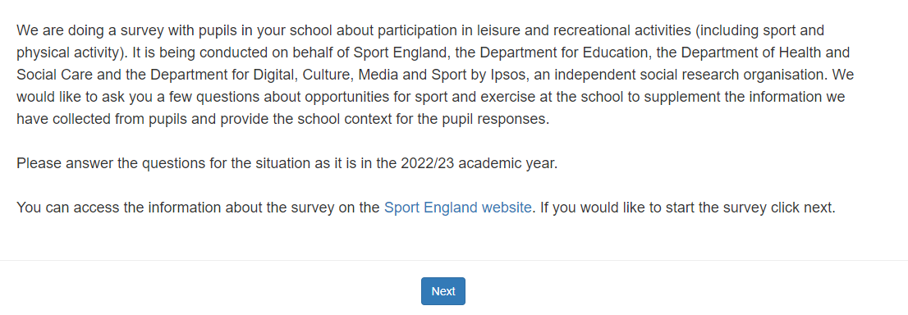

Teachers can access the survey at a later date using the URN provided.

Teachers will see the following screen.

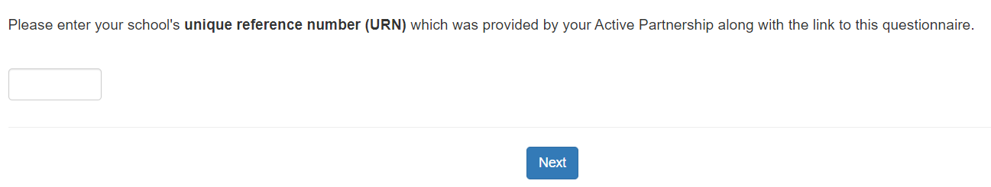

# Question 1

## Can we check, is this your school: [school name]?

* Yes
* No – you will be asked to enter your unique reference number again

# Question 2

Teachers will be shown school years based on school type, i.e., primary (show reception to Year 6), secondary (show Year 7 to Year 13), other (show all year groups) plus grouped year group.

## What school years does this school include?

* Reception
* Year 1
* Year 2
* Year 3
* Year 4
* Year 5
* Year 6
* Year 7
* Year 8
* Year 9
* Year 10
* Year 11
* Year 12
* Year 13
* All year groups from Reception to Year 13

# Question 3

The options shown will vary depending on the type of school, i.e., primary, middle, secondary, all through.

## Do you hold any PE or sport related roles in the school?

Select all that apply

* Specialist PE teacher
* PE lead/PE and Sport Co-ordinator
* School sports co-ordinator
* Sports specialist trainee or apprentice
* Sports coach
* School Games Organiser/Assistant School Games Organiser (SGO/ASGO)
* Other (please specify)
* None of these

# Question 4

The options shown will vary depending on the type of school, i.e., primary, middle, secondary, all through.

## Do you hold any of these leadership roles or responsibilities in the school?

Select all that apply

* Head teacher
* Deputy Head teacher
* Assistant Head teacher
* Curriculum area lead/Department Head/Head of Faculty
* Phase leader, e.g. Head of Early Years
* Lead for any non-curriculum areas (e.g. safeguarding, careers, co-curricular activities)
* SEN co-ordinator
* Other (please specify)
* None of these

# Question 5

## Has the school offered any training specific to PE, sport or physical activity in the last year to either yourself of colleagues? Please check with colleagues if you are unsure.

* Yes, but just to PE teachers
* Yes to PE and other teachers
* No
* Don’t know

# Question 6

## Which of the following facilities does the school have? Please report the facilities the school has available for use this academic year.

Options for Primary schools

Select all that apply

* Playing field on school site
* Playing field off the school site
* Multi use outdoor games area (MUGA)
* Netball or basketball court
* Tennis court
* Playground with climbing or swinging equipment for playtimes, including adventure playgrounds and trim trails
* Assembly hall available for indoor PE
* Sports hall
* Climbing or gymnastics equipment in hall
* Swimming pool (on school site)
* Access to a swimming pool off the school site
* Athletics or running track
* Field athletics facilities, e.g. long jump pit
* Climbing or bouldering wall
* Other specialist sports facility (please specify)
* None of these

Options for Secondary, Middle or All through schools

Select all that apply

* Grass playing field on school site
* Grass playing field off the school site
* Artificial or astroturf pitches on school site
* Artificial or astroturf pitches off the school site
* Multi use outdoor games area (MUGA)
* Netball or basketball court
* Tennis court
* Playground with climbing or swinging equipment, including adventure playgrounds and trim trails
* Assembly hall available for indoor PE
* Sports hall
* Climbing or gymnastics equipment in hall
* Gym or fitness room
* Dance studio
* Swimming pool (on school site)
* Access to a swimming pool off the school site
* Athletics or running track
* Field athletics facilities, e.g. long jump pit
* Climbing or bouldering wall
* Cricket nets
* Other specialist sports facility (please specify)
* None of these

# Question 7

Not asked if teacher answered ‘None of these’ for Question 6 or only answered ‘Access to a swimming pool off the school site’

## Does the school make any of these facilities available for community use?

By community use we mean any activity outside of school time or children’s education where facilities are used predominantly by community groups (for instance local sports clubs, or for adult education). Sharing facilities with other primary or secondary schools should not be included.

* Yes – for sport related reasons
* Yes – for non-sport related reasons
* Yes, for both sport and non-sport related reasons
* No
* Don’t know

# Question 8

Asked only if teachers answered ‘Yes’ to Question 7. Only options selected in Question 7 will be shown with the exception of ‘Access to a swimming pool off the school site’.

## Which of these facilities does the school make available for community use?

Select all that apply

# Question 9

## What, if any, extra facilities or equipment would help enhance your PE and Sport offer?

Options for Primary schools

Select all that apply

* Playing field on school site
* Playing field off the school site
* Multi use outdoor games area (MUGA)
* Netball or basketball court
* Tennis court
* Playground with climbing or swinging equipment for playtimes, including adventure playgrounds and trim trails
* Assembly hall available for indoor PE
* Sports hall
* Climbing or gymnastics equipment in hall
* Swimming pool (on school site)
* Access to a swimming pool off the school site
* Athletics or running track
* Field athletics facilities, e.g. long jump pit
* Climbing or bouldering wall
* Other specialist sports facility (please specify)
* None of these

Options for Secondary, Middle or All through schools

Select all that apply

* Grass playing field on school site
* Grass playing field off the school site
* Artificial or astroturf pitches on school site
* Artificial or astroturf pitches off the school site
* Multi use outdoor games area (MUGA)
* Netball or basketball court
* Tennis court
* Playground with climbing or swinging equipment, including adventure playgrounds and trim trails
* Assembly hall available for indoor PE
* Sports hall
* Climbing or gymnastics equipment in hall
* Gym or fitness room
* Dance studio
* Swimming pool (on school site)
* Access to a swimming pool off the school site
* Athletics or running track
* Field athletics facilities, e.g. long jump pit
* Climbing or bouldering wall
* Cricket nets
* Other specialist sports facility (please specify)
* None of these

# Question 10

## Does your school monitor how pupils travel to school?

* Yes
* No
* Don’t know

# Question 11

Primary, Middle and All through schools only.

## Does the school participate in Walk to School week or other similar initiatives promoting active travel to school?

* Yes
* No
* Don’t know

# Question 12

Secondary schools and those who responded ‘No’ or ‘Don’t know’ to Question 11.

## Does the school do anything to promote active travel to school?

* Yes
* No
* Don’t know

If a teacher skips Question 12 or responds, ‘Don’t know’, the following message is shown.

‘Remember, you can exit this survey entry and come back to it later if you need to gather information from colleagues. Your answer to this question contributes to your school’s rating under the ‘Healthy Schools Rating Scheme (DfE)’

# Question 13

## How long are break and lunch time at the school?

## If the length varies, please tell us the longest time that any pupils have.

Provide your answers in minutes

* Break time
* Lunch time

# Question 14

## Below are a number of school-based activities. For each one, please type in how many minutes a single session usually lasts at the school.

## Think only of activities involving sport and physical activity.

## Think of the time when pupils are doing the activities. Do not include changing time.

Provide your answer in minutes

* Before school sports or exercise clubs or training
* Lunch time sports or exercise clubs
* After school sports or exercise clubs or training

Not offered box shown under each type of club.

# Question 15

**Are PE or games lessons on a one or two week timetable?**

* One week timetable
* Two week timetable

**Question 16**

Primary schools - year groups shown will depend on response given in Question 2.

## How many minutes each week would a pupil typically spend doing PE lessons in school (i.e. curriculum PE)? Include changing time

## Provide your answers in minutes per week.

* Year 1-2
* Year 3-6

Secondary, Middle and All through schools - year groups shown will depend on response given in Question 2.

## For each year group, how much time each week do pupils usually spend doing PE or Games lessons in school (i.e. curriculum PE)? Please only think about core PE time, and ignore any additional time for those studying PE at GCSE.

## Provide your answers in minutes per week.

* Year 1-2
* Year 3-6
* Year 7-8
* Year 9
* Year 10-11

# Question 17

Year groups shown will depend on response given in Question 2.

## Thinking about a typical week, how many PE sessions do pupils have?

* Year 1-2
* Year 3-6
* Year 7-8
* Year 9
* Year 10-11

# Question 18

Only year groups selected in Question 2 will be shown.

## This year (2023-24) which year groups, if any, have had or will have swimming lessons provided by the school? Include swimming lessons arranged by the school, wherever they take place.

Please select all that apply

* Reception
* Year 1
* Year 2
* Year 3
* Year 4
* Year 5
* Year 6
* Year 7
* Year 8
* Year 9
* Year 10
* Year 11
* Year 12
* Year 13
* Swimming lessons are not usually offered

# Question 19

Asked if swimming lessons ARE offered – response to Question 17.

## How many school swimming sessions does each pupil get during the whole school year? Think only of standard swimming lessons, not swimming clubs or team training.

* Fewer than 10 (e.g. weekly sessions for half a term)
* 10-19 (e.g. weekly sessions for a whole term)
* 20-29 (e.g. weekly sessions for two terms)
* 30 or more (e.g. weekly sessions for three terms)
* None of these

# Question 20

Asked if swimming lessons ARE offered – response to Question 17.

## What is the length of the main swimming pool at the facility used by pupils for swimming lessons?

* Less than 25 metres
* 25 metres
* 30-33 metres
* 50 metres
* Other length – please specify

# Question 21

Only asked if school is a Primary, All through or Middle school.

## What would support your school to better deliver the national curriculum requirement that all children are able to swim at least 25 metres by the end of key stage 2?

* Additional teacher training in swimming and water safety
* Additional resources for teachers (includes funding)
* Having additional funding (to cover the costs of pool hire/transport etc.)
* Better access to facilities
* Higher priority placed on swimming with the school (this may include making more time available for swimming)
* Additional teacher/teaching assistant/volunteer available for swimming lessons
* Other (please specify)
* None of these
* Don’t know

# Question 22

## Which of the following activities are offered at the school during PE lessons? Include activities delivered by external providers if part of standard school lessons.

Select all that apply

* Swimming (including lessons at external pool organised by school)
* Football (include blind football and other adapted forms)
* Netball
* Basketball (include wheelchair basketball)
* Handball
* Dodgeball
* Hockey
* Rounders
* Cricket
* Tennis
* Badminton
* Table tennis
* Boccia
* Other team or ball sports (include goalball) (please specify)
* Multi-sports (including circuit training)
* Running or athletics
* Gymnastics or cheerleading
* Trampolining
* Dance
* Fundamental Movement Skills (balance, agility, co-ordination)
* Martial arts
* Golf or Tri-Golf
* Other sports or exercise activities

Primary option only

* Touch or tag rugby

Secondary, Middle, All through options only

* Rugby (include touch or tag rugby)
* Volleyball
* Gym or fitness suite training (include use of exercise machines, and circuit training)
* Outdoor or adventure activities

# Question 23

## Which of the following activities are offered at the school, before school, during lunchtime or at after school clubs? Include activities for pupils offered at school by outside providers. Include any clubs offered during this school year (2023/24) even if not currently on offer.

Select all that apply

* Swimming (including lessons at external pool organised by school)
* Football (include blind football and other adapted forms)
* Netball
* Basketball (include wheelchair basketball)
* Handball
* Dodgeball
* Hockey
* Rounders
* Cricket
* Tennis
* Badminton
* Table tennis
* Boccia
* Other team or ball sports (include goalball) (please specify)
* Multi-sports (including circuit training)
* Running or athletics
* Gymnastics or cheerleading
* Trampolining
* Dance
* Fundamental Movement Skills (balance, agility, co-ordination)
* Martial arts
* Golf or Tri-golf
* Other sports or exercise activities

Primary option only

* Touch or tag rugby

Secondary, Middle, All through options only

* Rugby (include touch or tag rugby)
* Volleyball
* Gym or fitness suite training (include use of exercise machines, and circuit training)
* Outdoor or adventure activities

# Question 24

Only asked to state funded schools

## At your school, has additional support been targeted at any of the following groups as a result of the PE and sport premium funding which all state-funded schools receive?

Select all that apply

* Boys
* Girls
* Those less engaged/least active in PE and sport
* Children lacking in PE skills, agility and confidence
* Children who are overweight or obese
* Disadvantaged children (e.g. those eligible for free school meals)
* Children with SEN or disability
* Gifted and talented/more able children
* Specific year groups
* Other please specify
* No targeting of specific groups

# Question 25

Only asked to Primary and Middle Schools.

## Which, if any, of the following activities does the school do to support the transition of pupils from primary to secondary school?

Select all that apply

* Offer an introduction to sports which are part of the secondary curriculum
* Teach children the fundamental skills needed to access the secondary PE curriculum
* Engage with local secondary schools to ensure a smooth transition for pupils
* Other (please specify)
* No, none

# Question 26

Only asked to Secondary, Middle and All through Schools.

## Which, if any, of the following activities does the school do to support the transition of pupils from primary to secondary school?

* School staff or pupils assist primary schools in delivering activities such as PE lessons
* Schools run taster sessions, induction days, holiday sports camps or clubs open to primary pupils
* Schools run sports competitions or events for primary schools to participate in
* Has a dialogue with their feeder primary schools
* Support primary schools to offer an introduction to secondary school sports for pupils
* Other (please specify)
* No, none

Now there are two questions about school food, included because they relate to pupils’ more general health and wellbeing. If necessary, please consult another member of staff in answering these questions. You can look at the next two questions, close this entry, and come back to it later after consulting colleagues.

# Question 27

## How does the school provide food education for all pupils and develop their skills in preparing nutritious meals?

Select all that apply

* Pupils are encouraged to support catering staff in the preparation and serving of school food
* School has some food grown on-site by students which is used for preparation of school meals
* School supports teaching staff in their professional development around food and nutrition
* School runs an extra curricular cooking club at least once per month, open to all pupils
* Other initiatives
* None of these
* Don’t know

Primary option only

* School ensures healthy eating is a priority in the curriculum

Secondary, Middle, All through options only

* School ensures healthy eating is a priority in food technology or PSHE classes

Secondary and All through options only

* School routinely provides cooking lessons as part of the curriculum at Key Stage 4

‘Remember, you can exit this survey entry and come back to it later if you need to gather information from colleagues. Your answer to this question contributes to your school’s rating under the ‘Healthy Schools Rating Scheme (DfE)’

# Question 28

## How does the school ensure that it is complying with the School Food Standards (SFS)?

Select all that apply

* School ensures SFS compliance is included in catering contract
* School gains at least annual assurance over SFS compliance from caterers/local authority
* School is part of a food or menu award, accreditation, audit or inspection scheme (such as Food for Life or Healthy Schools London)
* School ensures catering staff are trained and supported in providing meals that meet the School Food Standards
* School has nominated governor with specific responsibility for school food
* School complies with the SFS throughout the school day, including during school lunches, break-times and before or after school clubs
* School goes beyond SFS and has a school food policy which bans pupils from bringing in food or drink high in sugar, salt or fat
* Other initiatives
* None of these
* Don’t know

‘Remember, you can exit this survey entry and come back to it later if you need to gather information from colleagues. Your answer to this question contributes to your school’s rating under the ‘Healthy Schools Rating Scheme (DfE)’

# Final screen

## Thank you for taking part in this survey.

Answers are automatically submitted. Once teachers reach this screen they can close the browser.